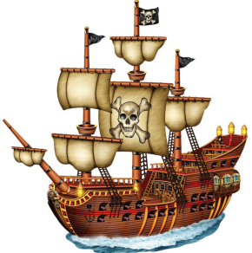
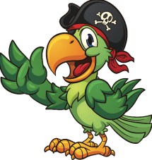
Year 2: Spring Term 2018
Homework Tasks
Choose one task each week. Colour in the star when it’s complete!
English tasks:
Message in a bottle! Pretend you are stranded on a desert island. Write a message to somebody you know asking them to rescue you! Remember to include capital letters, full stops and a description of where you are!
Character description of a pirate Either find a pirate or create your own, write a description of what your character looks like, their personality and their likes and dislikes. Try to include interesting adjectives and conjunctions such as ‘but’ and ‘because’.

Spellings Using the spellings given, create some interesting silly sentences. Can you include capital letters, finger spaces and the correct punctuation?

Treasure map Design a treasure map and write at least 6 instructions on how to find the treasure. Number your instructions, time connective (first, then, next) followed by an imperative verb (walk, dig, look, find).
Remember to read regularly to an adult. Please ensure you record it in your reading record diary so you can earn stickers! Also, remember phonics homework!
stci
Art/Design Technology tasks:
Using junk modelling, create a pirate boat!

Create a treasure box using a range of materials.

Create a telescope!
Maths
To ensure children are regularly undertaking maths homework, we will be sending differentiated maths activities every 2 weeks. This will be in addition to the other homework choices on this sheet.

Geography tasks:
Name the different oceans found in the world. Label them on a map and write a fact!

On a map, label the different continents in the world.
History tasks:
Create a poster about a famous pirate. Try and include a title, facts and a caption to go under
your pictures.

Create a timeline of famous pirates. You must write in their names and key dates.

Science tasks:
Using objects around your house, can you identify items that float and sink?
Create a poster on a chosen material. Can you explain what the material looks like and items that can be made out of it?
You are a pirate. You have a pet parrot who doesn’t like the sea spray. Which material could you use to create a parrot raincoat? Create a labelled diagram of your design.

