YEAR 3
Mysterious Mummies
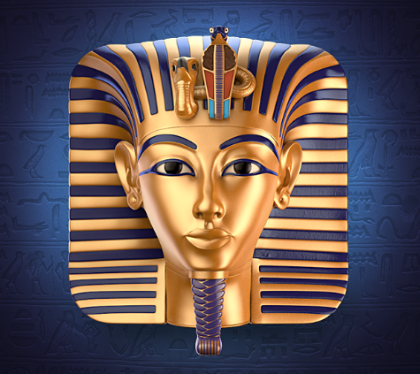

Spring Term 2018
Homework Project Booklet
Welcome to the Spring Term homework booklet! Here you are presented with a choice of tasks to complete over the term, many of which are linked to your topic.
Introduction
Each week you must complete a maths task (usually set by your teacher*) and one other activity selected from the booklet. Please continue to hand in your homework book weekly on a Wednesday for checking progress and marking.
The activities are organised by subject. To achieve a good balance over the term, the booklet shows the minimum number of tasks to be completed for each subject.
* Maths
If there is no specific maths homework set by your teacher, please practise one of the maths objectives from the back of the booklet.

English: choose at least 5 tasks

- Read daily! Write a response to your reading:
- Write a ‘blurb’ for the back cover
- Describe a favourite character
- Recount part of the story in your own way
- Write a letter to a character
- Write a book review
- Read to someone and ask them to write a comment
- Practise spellings from the year ¾ word list (back of booklet)
- Write your own short story set in Ancient Egypt!
- Write a list of verbs in their PRESENT and PAST forms:
e.g. run ran eat ate
- Write an acrostic poem for the words ANCIENT EGYPT
- Make a list of homophones e.g. meat and meet. Write a sentence that includes each word
- Practise writing sentences with possessive apostrophes. e.g. The Pharaoh’s robes were laced with gold.
- Write a glossary of Ancient Egypt topic words e.g. sarcophagus

Science: choose at least 2 tasks

- Create a poster that explains how part of the body works e.g. skeleton, muscles, heart, digestive system
- Find examples of animals that are either carnivore, herbivore and omnivore. Write down what they eat.
- Experiment: Put some white carnations in some water that has food colouring in it. Observe and record what happens after a few days. You could take photos to put with your explanation.

History: choose at least 1 task

- Ancient Egypt: Find out who was known as the ‘boy king’ and present your findings as a fact file.
- Find out what items were buried with a mummy for its journey to the afterlife.

Geography: choose at least 1 task

- Where are the major deserts of the world? Perhaps show them on a simple outline map.
- Find out about the River Nile. How long is it? Where does it start and finish? Why is it important? What do people use it for?

Art / Design and Technology: choose at least 1 task

- Create your own hieroglyphic symbols for letters of the alphabet. Then write a message using your new symbols!
- Make your own Ancient Egypt artefact and bring it in for display in class e.g. a model sarcophagus, pyramid or canopic jar.

**If no specific maths homework is set, try practising one of the objectives below **

Maths: Year 3 Key Objectives

Number and Place Value:
- count from 0 in multiples of 4, 8, 50 and 100
- find 10 or 100 more or less than a given number
- compare and order numbers up to 1000
- read and write numbers up to 1000 in digits and in words
Addition and subtraction:
Add and subtract numbers mentally, including:
- a three-digit number and ones
- a three-digit number and tens
- a three-digit number and hundreds
- Add and subtract numbers with up to three digits
- solve missing number problems
Multiplication and division
- Know the 3, 4 and 8 times tables
- Know the division facts for these tables
- Use times table knowledge to multiply a two-digit number by a single digit number e.g. 19 x 4 is (10 x 4) plus (9 x 4)

Fractions
- Count up and down in TENTHS
- Find a fraction of a set of objects e.g. ¼ of 20 sweets
- Recognise equivalent fractions in shapes e.g. $\frac{1}{2}$ = $\frac{2}{4}$ of a pizza

Measurement
- Measure perimeter of 2D shapes (with a ruler OR given the measurement of one or more sides)
- Add and subtract money, calculating the change
- Know the Roman Numerals from I to XII (1 to 12)
- Tell and write the time in 12 and 24 hour clock format
- Know the number of seconds in a minute and the number of days in each month, year and leap year
Geometry
- Recognise 3D shapes in different positions
- Identify right angles
- Identify right angles in quarter, half and three-quarter turns
- Identify horizontal and vertical lines
- Identify perpendicular and parallel lines
Statistics
- Understand and present data using bar charts, pictograms and tables

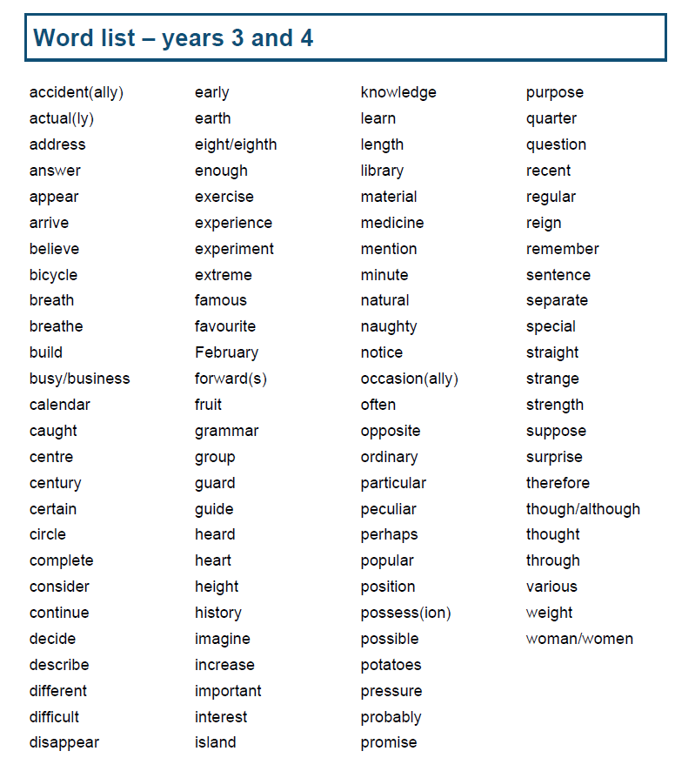
(for spelling practice)

