YEAR 4
Roaming Romans
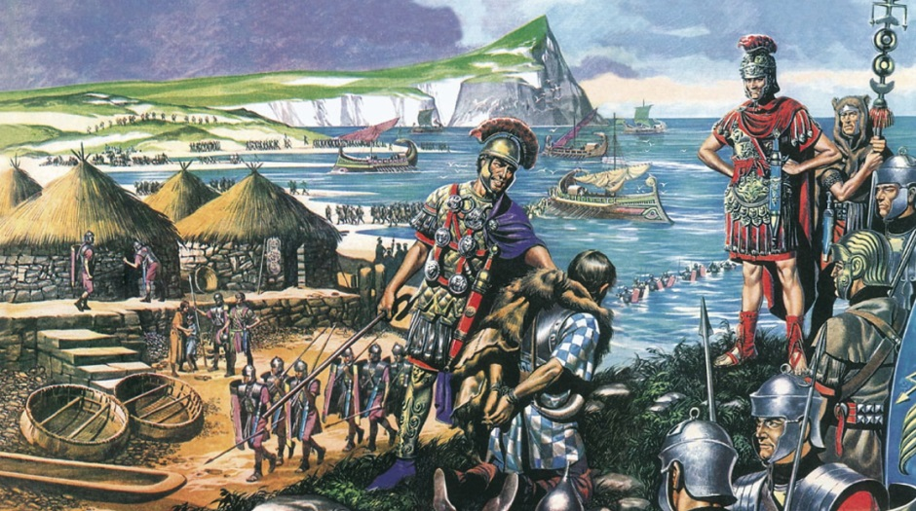

Spring Term 2018
Homework Project Booklet

Introduction
Welcome to the Spring Term homework booklet. Here you are presented with a choice of tasks to complete over the term, many of which are linked to your topic.
Each week you must do your best to learn your weekly spellings. Please continue to hand in your homework book weekly on a Wednesday for checking progress and marking.
The activities are organised by subject. To achieve a good balance over the term, the booklet shows the minimum number of tasks to be completed for each subject.
* Maths
If there is no specific maths homework set by your teacher, please practise one of the maths objectives from the back of the booklet.

English: choose at least 5 tasks

- Read daily! Write a response to your reading:
- Write a ‘blurb’ for the back cover
- Describe a favourite character
- Recount part of the story in your own way
- Write five facts you have learnt from a non-fiction book
- Write a book review
- Read to someone and ask them to write a comment
- Practise spellings from the year 3/4 list (back of booklet)
- Form sentences using spellings from the year 3 / 4 spelling list.
- Learn our class story with the use of your storyboard
- Write a fact file about a favourite author

Science: choose at least 2 tasks

- What liquids, solids and gases do you have in your home? Draw a table to list them all. Do any of these change state when temperatures change? What happens to them?

- Topic: choose at least 2 tasks

- Draw a map showing the Roman Empire.
- Write some facts about Boudicca.
- Imagine you are a spectator at a gladiator battle or chariot race! Write a description of the event.
- Find out about a famous Roman site in Britain and present your findings.
- Research some famous Roman Baths.
- Create a 3D structure of a famous Roman Building for our display.
- Write some TRUE and some FALSE statements under the heading: What have the Romans done for us?

Art and design: choose at least 1 task

- Design and create a Roman mosaic using materials of your choice. (Choose a simple motif.)
- Choose an activity from: http://timetravellerkids.co.uk/fun-stuff/free-projects/roman-craft-projects/

**If no specific maths homework is set, try practising one of the objectives below **

Maths: Year 4 Key Objectives

Number and Place Value:
- Count in multiples of 6, 7, 9, 25 and 1000
- Find 1000 more or less than a given number
- Count backwards through zero to include negative numbers
- Recognise the place value of each digit in a four-digit number (thousands, hundreds, tens, and ones)
- Order and compare numbers beyond 1000
- Round any number to the nearest 10, 100 or 1000
- Read Roman numerals to 100 (I to C)

Addition and subtraction:
- Add and subtract numbers with up to 4 digits, in a column
- Estimate to check answers
- Solve addition and subtraction problems, deciding which operation needs to be used

Multiplication and division:
- Times tables up to 12 x 12
- Division facts for all the times tables
- Multiply 3 numbers together
- Multiply two- and three-digit numbers by a single digit

Fractions:
- Recognise and show equivalent fractions e.g. $\frac{2}{3}$ ≡ $\frac{4}{6}$ ≡ $\frac{10}{15}$
- Count up and down in hundredths
- Calculate fractions of quantities e.g. $\frac{2}{5}$ of £1
- Write decimal equivalents to ¼ ½ ¾ and any number of tenths and hundredths
- Divide one- or two-digit numbers by 10 and 100
- Round decimals (one decimal place) to the nearest whole number
- Order decimal numbers (up to two decimal places)
- Solve money problems involving decimal notation for £ and p.

Measurement:
- Convert between units of measure e.g. kilometres to metres, hours to minutes
- Calculate the perimeter of shapes in centimetres and metres
- Calculate the area inside a shape by counting squares
- Read, write and convert between analogue and digital times (12 hour and 24 hour clock)
- solve problems involving converting from hours to minutes; minutes to seconds; years to months; weeks to days.

Geometry:
- Identify angles smaller or bigger than a right angle
- Identify lines of symmetry in 2-D shapes
- Complete a figure across a line of symmetry
- Describe positions as coordinates on a grid

Statistics:
- Present and interpret data in bar charts and time graphs
- Solve problems using information presented in a variety of charts, pictograms, tables and graphs

