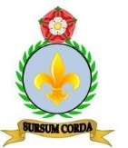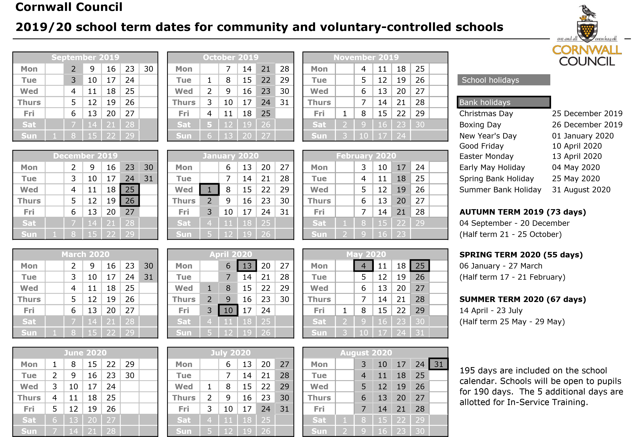

**Bank Holidays - school closed**

Christmas Day 25th December 2019

Boxing Day 26th December 2019

New Year’s Day 1st January 2020

Good Friday 10th April 2020

Easter Monday 13th April 2020

May Holidays 4th and 25th May 2020

Summer 31st August 2020

**Autumn Half Term - school closed**

21st - 25th October

**Spring Half Term - school closed**

17th - 21st February

**Summer Half Term - school closed**

25th - 29th May

**Staff Training Days - school closed**

* Wednesday 4th Sept 2019
* Monday 28th October 2019
* Monday 6th January 2020
* Monday 24th February 2020
* Monday 1st June 2020
* Thursday 23rd July 2020

**St. Mary’s Catholic Primary School**

**2019/20 Term Dates**