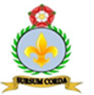
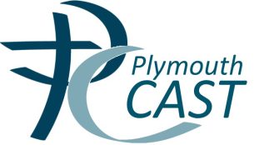
Administration Assistant

St Mary’s Catholic Primary School, Penzance are seeking to appoint a positive and inspiring Administration Assistant, to work in the school office, for 29th October 2018.
We offer:
- A welcoming school with a strong Catholic ethos
- Children who are polite, happy and motivated to learn
- A supportive staff team who genuinely want the best for our pupils
- A commitment to your own professional development
The successful candidate will:
- Be happy to support the Catholic ethos of our school
- Be dedicated to raising standards and be a good role model
- Have excellent organisational and communication skills
- Be dynamic, resilient and hard working with a positive nature
- Be able to work as part of a team and establish positive relationships with pupils, parents, governors and staff
- Have a reflective and evaluative approach to their practice
Required Date: 29th October 2018
Salary: Grade C £15,916 per annum (pro rata’d to hours worked if part time)
Contract: Permanent
Hours/Weeks per year: 20 hours term time only
Visits to the school are encouraged. To arrange a visit, please contact Jackie Merriman, Secretary by email at jackiemerriman@st-marys-rc-pz.cornwall.sch.uk or contact the school on 01736 330005.
We are committed to safeguarding and promoting the welfare of children and young people and expect all staff and volunteers to share this commitment. An enhanced DBS Disclosure is required for this post.
Closing Date: 12th October 2018
Interviews: 16th October 2018
Shortlisted candidates will be notified by email
Application packs can be found on the School Website address:
www.st-marys-catholic.eschools.co.uk

